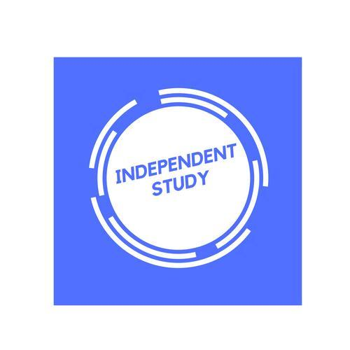 | Independent Learning in  Spanish

After each lesson, in addition to completing any work set, a pro-active independent learner would……  - Ensure notes are completed and filed in the correct section of your folder.  - Catch up on work missed  - Research any news/events taking place in the Spanish speaking world  - Read the relevant grammar/vocab and ensure full understanding.  - Make a list of each grammar point you do not fully understand to share with  staff, so this can be revised.  - Create vocab/sentence banks to help revise topical vocab.  - Create mind maps for each sub topic, with facts and data you can include in the speaking exam.  - Purple pen and redraft written work such as essays, summaries and  translations.  - Revise vocabulary using Memrise or Quizlet  - Listen to Spanish podcasts.  - Download and complete additional worksheets on Kerboodle.  - Complete the interactive activities on Kerboodle. | Effort Grade
Resources to help you study: Past Papers can be found on the P Drive
Resource | Description
El país | An excellent website to keep up to date with Spanish news.
Kerboodle | This is the link to our core textbooks. AQA AS Level Spanish (Year 1) / AQA A level Spanish (Year 2)
SpanishDict | A good website which can be used as a dictionary, but also has classes on tenses and grammar.
Memrise | A link to the core vocab from AS (Year 1)
Memrise | A link to Spanish essay and speaking phrases
StudySpanish | A website which explains and tests grammar
Stretch yourself- Watching Spanish films and TV shows, as well as reading books will help boost vocab and grammar retention.

