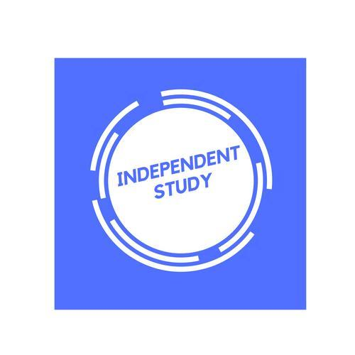 | Independent Learning in Psychology

Resources to help you study
Key resources, such as exam specification, checklists, past papers and mark schemes, exam technique and advice can be found on TEAMS or P:Drive.
Resource | Description
Student checklist sheets | You should have one of these that closely follows the specification and what you should have in your notes
Psychology AS/1L – The complete companion | This is the course textbook for Year 1 content
AQA A Level Psychology 2 | This is the course companion for the 2nd year
Explore | Psychology | tutor2u | Navigate your way around this useful website to find key study notes, revision webinars and top tips for exam success.
Simply Psychology | A good website with an overview of key areas linked to the specification. You can use this to help clarify lesson content or extend your learning.
A to Z of psychology | BPS | A useful glossary of key psychological terms.
Stretch yourself-
Sign up to the British Psychological Society and receive their emails on their latest psychological research out there. Access Psychological Review magazines to deepen your learning from your class teacher.

Independent Learning in

After each lesson, in addition to completing any work set, a pro-active independent learner would…… | Effort Grade
Resources to help you study

Resource | Description
Stretch yourself-

