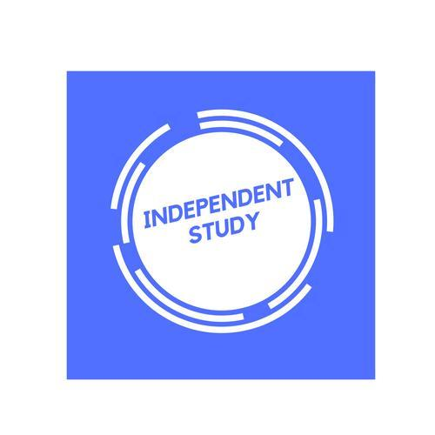 | Independent Learning in  English Literature

After each lesson, in addition to completing any work set, a pro-active independent learner would……  - Ensure notes are completed and filed in a folder.  - Catch up on any missed lessons before the next lesson.  - Read the relevant parts of text/contextual text(s) and annotate lesson notes with additional information.  - Make a list of things not fully understood to be reviewed and discussed for a future lesson.  - Email your class teacher for any clarification of areas not fully understood.  - Complete practice essays and improve if needed when you have received feedback.  - Read through any exemplar material you are given and annotate with assessment objective notes.  - Re-read your set texts several times annotating closely and building a bank of quotations to learn by heart.  - Read relevant critical essays and annotate with the appropriate text to link relevance.  - Read relevant current affairs and link to appropriate set texts.  - Read relevant contextual and historical articles, making links to set texts. | Effort Grade
Resources to help you study
Resource | Description
A Level mark book with assessment criteria. | For you to keep an eye on your own progress and any re-drafts of essays.
Bl.uk | Useful website for The British Library, giving you online access to texts, accessible articles, context and much more.
AQA English Literature  https://www.aqa.org.uk/subjects/english/as-and-a-level/english-literature-b-7716-7717/teaching-resources | Exam board website for past questions and overviews
https://www.aqa.org.uk/resources/english/as-and-a-level/teach/textbooks | Textbook for AQA Literature B to be found here.
https://www.english.cam.ac.uk/classroom/terms.htm | One of many online websites for literary definitions.
Stretch yourself-
Read critical articles and essays on your set texts. Research independently contextual historical information for each text. Make perceptive links to current affairs by reading about global, cultural, political, environmental and scientific events.

