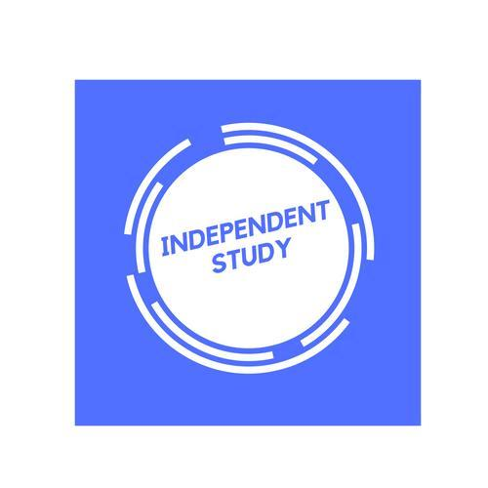 | Independent Learning in  IT

After each lesson, in addition to completing any work set, a pro-active independent learner would……
- Ensure that any work not completed in lesson is finished for next lesson
- if a lesson is missed catch up before the next lesson
- at the start of the lesson read the lesson instructions and make sure you know what the big picture is
- use your knowledge organiser or Course work help guide to identify what you need to do next and two cheque that you have completed all the required tasks
- make sure you fully understand the theory and instructions and ask if you are not sure
- if you stuck I need to clarify something you should email speak to me to address any issues
- when you are given feedback use that purple pen in exam unit to respond to the feedback and improve your answers
- when you are given feedback for your coursework ensure that you do it to the best of your ability
- read deeper into the topics covered try to find out more and add your own research findings, particularly in course work
- Read ahead before the lesson most times I will have posted the lesson over the weekend so you should be able to work out what is happening over the week.
Resources to help you study
Resource | Description
https://www.csnewbs.com/ocr-cambridge-technicals | Cambridge technical in IT in a nutshell
Teams site > files | Check your files section for help guides and resources
https://tinyurl.com/y5e2sy7b | The textbook Covers all units- exam and coursework.
Stretch yourself-
Research beyond what we cover in the classroom. If you cover a topic you don't know much about, try Googling it. I say if you can find out more
you can also keep an eye out on BBC News and other news websites for recent developments and events in the technology industry. it helps an exam and password units if you can apply real life examples when you are writing about a given topic.

