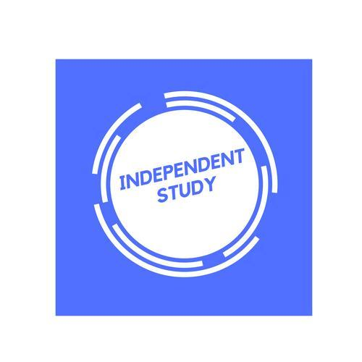 | Independent Learning in English Language

Resources to help you study: Key resources, such as exam specification, checklists, past papers and mark schemes, exam technique and advice can be found on TEAMS or P:Drive.
Resource | Description
Student feedback sheets | You should have a booklet with the specification and space to fill in your feedback from essays.
English Language A / AS Level for AQA Student book ISBN: 978-1-107-46562-6 | This is the course textbook for both years
Accents and dialects | British Library - Sounds (bl.uk)  https://getrevising.co.uk/revision-notes/english_language_revision_language_and_gender (83) LancasterLAEL - YouTube | Navigate your way around these useful websites to find key study notes, revision webinars and theorists for the main topics of the course.
AQA | English | AS and A-level | English Language | The exam board’s website with an overview of key areas linked to the specification. You can use this to help clarify lesson content or extend your learning.
https://filestore.aqa.org.uk/resources/english/AQA-7701-7702-GLOSSARY.PDF | A useful glossary of key metalanguage.
Stretch yourself:  Follow varied linguistic groups on Twitter. | You could start with the following: @SussexLinguist @uwelingo @lingsoc @EnglishthruEngl @EngLangBlog @LinguisticsGuru @LanguageCrawler

