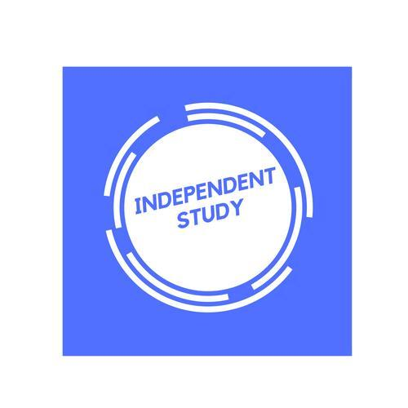 | Independent Learning in  Art | 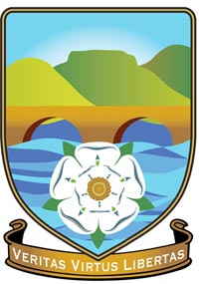

After each lesson, in addition to completing any work set, a pro-active independent learner would……  - Use the sixth form art room in their free periods to continue with their work where they won’t be distracted by others.  - You will continue to work on your skills by practicing your skills in the scruffy books provided you.  - You will take all feedback about the work and develop it and work on the improvements.  - Seek out sources of information for your essays and remember to keep a bibliography. Use teams to store your essays on to keep them safe.  - Arrange for additional support outside of your class time.  - To use the internet and books to look up new artists and ideas for your topic to discuss in the next lesson. | Effort Grade
Resources to help you study  Resource Description  Art Handbook This is on Teams and allows you to get the information you need for the course.  Help sheets Eventually will be in boxes on the wall, but also available on teams.  Internet Keep a list of useful websites in your scruffy books that you can return to, to refer later on.  Stretch yourself- Sign up to different art galleries and museums so you can see exhibition offers in advance. Take up opportunities outside of school such as life drawing lessons, pottery etc to open you up to different options. | Resources are open to interpretation as you are all studying different themes, so there will not be just one book or website for all of you and we don’t go over past exam papers as the papers aren’t a revision source like other subjects, for example- 1 year could be Human Form the next could be Recycling.

