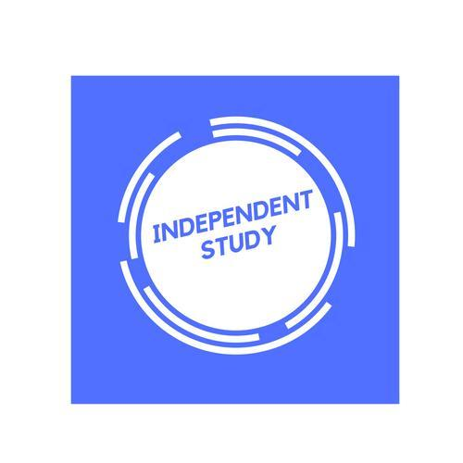 | Independent Learning in  Business

After each lesson, in addition to completing any work set, a pro-active independent learner would……
For portfolio work,
- Complete all tasks aiming to get work in before the deadline to get feedback.
- Use exemplar material to check depth of writing.
For examination units
- Ensure that notes are completed and filed properly in your folder for each learning objective and unit.
- Read the relevant textbook pages and annotate lesson notes with additional information and research
- Use the PLC for each enquiry question and identify which areas need looking back over
- Redraft exam questions after feedback has been given
- Use the mark schemes and self-mark exam questions. Look at examiner reports.
- Have a copy of the specification and read ahead for the next topic/lesson.
- Listen to podcasts, watch the news, and keep up to date with current affairs. Add these into your notes into the relevant units.
Resources to help you study
You are provided with a textbook and a revision guide. On Teams/Public drive there are many resources each learning objective.

www.businessed.co.uk This has all the units we study and provides theory notes for Unit 1,2 and 4.

M SAMULEWSKI - YouTube – Step by step guides to many concepts needed for the course.

Dragon’s Den allows you to see into the minds of inventors and entrepreneurs.

Inside the factory show the factors of production - https://www.bbc.co.uk/programmes/b07mddqk

www.tutor2u.net – A site full of presentations, news stories of business terminology.

Stretch yourself-

Sign up for a course on Future Learn. Focus your course on business. FutureLearn: Online Courses and Degrees from Top Universities

